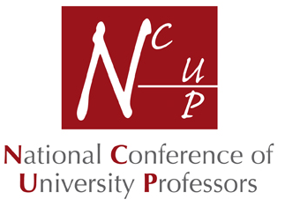 | President: Professor Roger Watson  Patron: Pauline Perry, Baroness Perry of Southwark  Mrs Cheryl Humphrey  NCUP Executive Officer  1a Winterhill Way  Guildford  GU4 7JX  Tel: 07587 282627  Email: secretariat@ncup.org.uk

Charity Gift Aid Declaration

Boost your donation by 25p of Gift Aid for every £1 you donate.

Gift Aid is reclaimed by the charity from the tax you pay. Your address is needed to identify you as a current UK taxpayer.

To make a Gift Aid declaration for your membership subscription, please tick the box below. Please note that this is not a request for additional payment and is only for record-keeping purposes, which may be disclosed to HMRC upon request.

I want to Gift Aid my past membership subscriptions and any donations I make in the future to The National Conference of University Professors.

I am a UK taxpayer and understand that if I pay less Income Tax and/or Capital Gains Tax in the current tax year than the amount of Gift Aid claimed on all my donations it is my responsibility to pay any difference.

My Details

Title ____________________ First name or initial(s) _________________________________
Surname _____________________________________________________________________
Full Home address _____________________________________________________________ _____________________________________________________________________________ _____________________________________________________________________________ Postcode _________________________ Date ________________________________________

Please notify the charity if you:
• want to cancel this declaration,
• change your name or home address,
• no longer pay sufficient tax on your income and/or capital gains.

If you pay Income Tax at a higher or additional rate and want to receive the additional tax relief due to you, you must include all your Gift Aid donations on your Self-Assessment tax return or ask HM Revenue and Customs to adjust your tax code.

