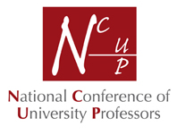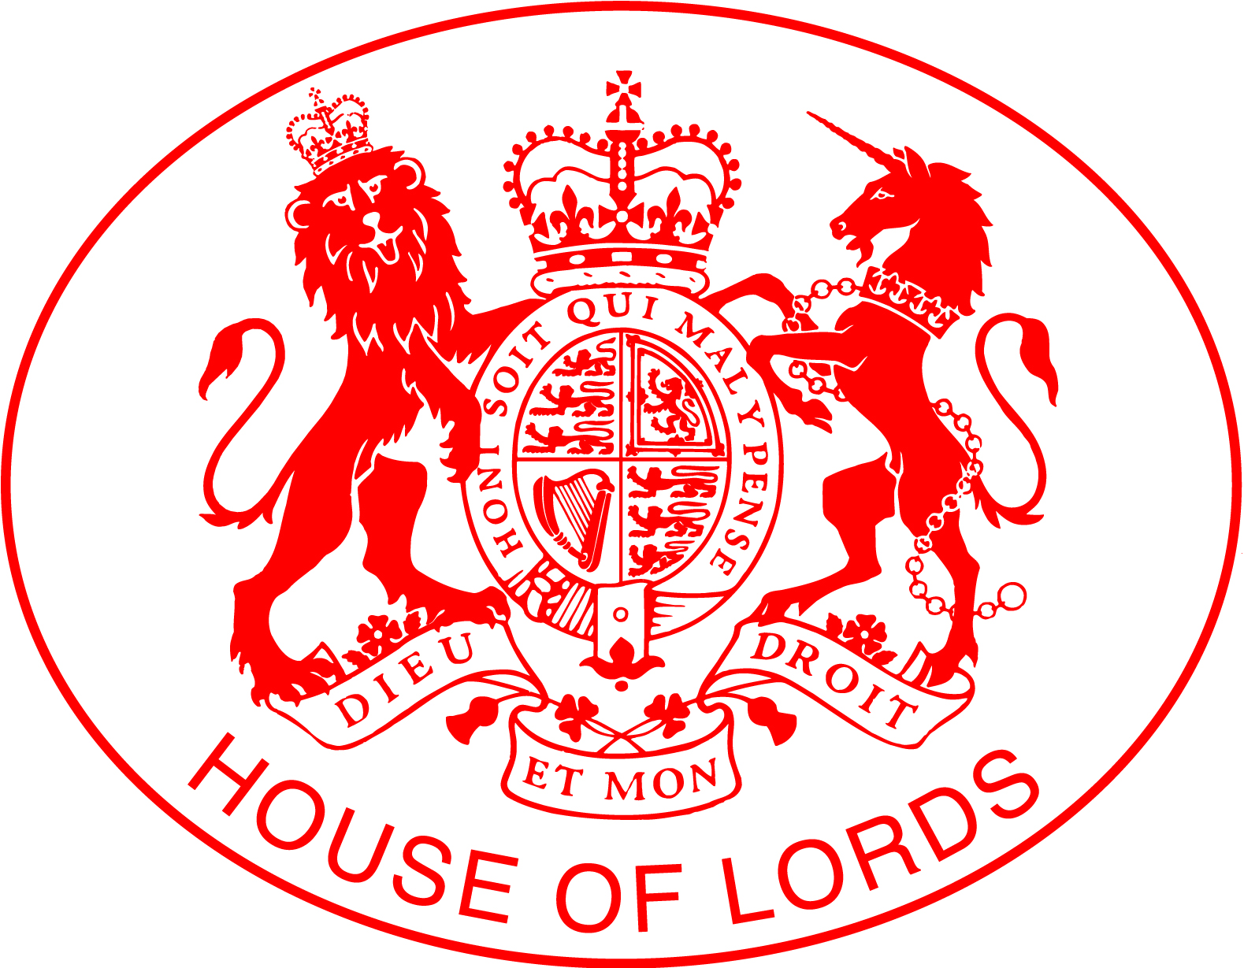  House of Lords  PATRON  The Rt Hon the Baroness Perry OF SOUTHWARK  Lord Inglewood address  future prospects for higher education  LunchEON  In the Cholmondeley Room & Terrace  May 9th. 2017, 12.30pm – 2.30pm  Our Patron, Baroness Perry of Southwark will be hosting the NCUP luncheon together with Lord Inglewood.  If you would like to attend this event, please complete the form adjacent. For further details about NCUP membership or this event email: Mrs Cheryl Humphrey, secretariat@ncup.org.uk  Lord Inglewood  William Richard Fletcher-Vane, The Lord Inglewood MRICS is a barrister and Chartered Surveyor, and has an MA in Land Economy from Trinity College Cambridge. He was a Minister in John Major’s Government, serving as a Whip and Deputy Chief Whip in the House of Lords in 1995 and as a Parliamentary Under Secretary of State at the Department of National Heritage 1995-97 where he was responsible for broadcasting and heritage. Between 1989-1994 and 1999-2004 he was a Member of the European Parliament where he was the Conservative spokesman on Legal Affairs and Chief Whip in 1994. He was Chairman of the CN Group, an independent local media business based in Carlisle 2002-2016, Chairman of Carr’s Milling Industries PLC 2005-2013, and of the Reviewing Committee on the Export of Works of Art 2003-2014. Between 2011-2014 he was Chairman of the House of Lords Select Committee on Communications, and 2014-2015 Chairman of the Select Committee on Extradition Law.  He was a Member of the House of Lords’ Select Committee on National Policy for the Built Environment 2015-2016, and has been a member of the House of Lords International Relations Committee since 2016. He was a visiting parliamentary fellow at St Antony’s College Oxford 2014-2015. He has been Chairman of the Cumbria Local Nature Partnership since 2013, Chairman of Gen2 since 2016, President of the Ancient Monuments Society since 2015, and President of the British Art Market Federation since 2014. He lives at Hutton-in-the-Forest in Cumbria. | Mrs Cheryl Humphrey: NCUP Secretariat  36 Great Oaks Park, Guildford, Surrey GU4 7JG  I would like to reserve ____ places at the House of Lords NCUP luncheon on  May 9th 2017  Please tick relevant boxes I request an invoice to be sent. c  I wish to join the NCUP and attend this reception (see below) c  Professors returning an application for NCUP membership and attendance at this reception may join at a reduced rate.  Full Membership of the NCUP is only open to those who hold or have held, the title of “Professor” or “Visiting Professor” in a UK university.  *For Associate NCUP membership for senior non-professorial colleagues please contact the secretariat for how to apply.  Applicants and guests do not have to be professors.  For further information about NCUP, see Website www.ncup.org.uk  The cost for this event which includes: a drinks reception, full seated luncheon, and wine during lunch and speeches will be:  Non NCUP Member £85.00  All NCUP Members £75.00  Join the NCUP as full member or Associate member* & attend this Luncheon -£95.00  Title.................. Name...…………………………………………………………  Address…………………..……………………………………………………….  ………………………………...……………………………………………………  Postcode………………....……..Phone: ……..................……………………  Email: ……………………........................………………………………………  If not paying online via Eventbrite, please enclose a cheque for total payment  Total payment for _____ places = £__________________  Names of accompanying guests____________________________________________  Cheque payable to NCUP.  BARONESS PERRY  Baroness Perry is an educationalist, a Conservative politician and a member of the British House of Lords. In 1981 she became Her Majesty's Chief Inspector of Schools in England. In 1986 she became Vice-Chancellor of South Bank Polytechnic, and serving during its transition to a university became the first woman in history to run a British university. In 1994 Baroness Perry was Head of Lucy Cavendish College in Cambridge University, following which she became Pro Chancellor of Surrey University, where the Chancellor was the Duke of Kent.  For more than 40 years, Baroness Perry has made a major contribution to Higher Education in many roles, including: President of the Foundation for Higher Education, Chair of Governors and Trustee of Roehampton Institute and chair, trustee and president of many higher education establishments.  Baroness Perry hosted the NCUP House of Lords Luncheon in April 2016, speaking on “What is the role of Government in Higher Education”. In October 2016 Baroness Perry became the Patron for the National Conference of University Professors.

