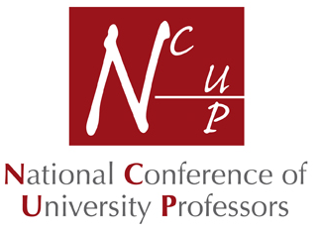 | President: Professor Margaret Cox, OBE  FKC, Kings College London  Mrs Cheryl Humphrey  NCUP Secretariat  36 Great Oaks Park  GUILDFORD  Surrey GU4 7JG  Tel: 07587 282627  Email: secretariat@ncup.org.uk
APPLICATION FOR FULL MEMBERSHIP (FNCUP) OF THE
NATIONAL CONFERENCE OF UNIVERSITY PROFESSORS

Professors wishing to join the NCUP should complete this form and return it to the NCUP Secretariat (address above) together with a cheque or completed standing order form. BACS payments can also be made to Lloyds Bank, NCUP Treasurers Account, Sort Code 30-95-46, Account No. 02920689

Full Membership for those wishing to pay by cheque is £50. For those wishing to set up a standing order, annual membership is £45 (an annual saving of £5).

Retired/Emeritus Membership is £20 per annum (whether by cheque or standing order). The membership fee is tax deductible.

Life Membership for Retired Members is a one-off payment of £150 for age under 65, £100 for age 65 to 80, or £50 for age over 80.

Name: Professor …………………………………………………………………………………….…………. MALE / FEMALE

Department: ………………………………………………………………………………………………………………….…..…..

University: ……………………………………………………………………………………………………………………………..

Work Address: …………………………………………………………………………………………………………………………

……………………………………………………………………………………Post Code ………………………………………….

Home Address: ………………………………………………………………………………………………………………………..

…………………………………………………………………………………….Post Code: …………………………..…………..

Email: ………….…………………………………………………………. Work Telephone: ………………………………………

Home No: ……………………………………………………… Mobile No. ………………………………………………………..

Please tick as appropriate:

[ ] I enclose a cheque for £50 / £20

[ ] I enclose a cheque for £150, £100 or £50 – one-off, life membership for retired members.

[ ] I enclose a completed standing order form to receive £5 discount on annual subscriptions for full membership.

WWW.NCUP.ORG.UK
31.3.17

